Martes 12 de mayo, 2020
1º ESO

Para dudas, puedes contactar conmigo en el siguiente e-mail: miguel.sanjose@sanviatorvalladolid.com

UNIDAD 3
Workbook Pag. 22
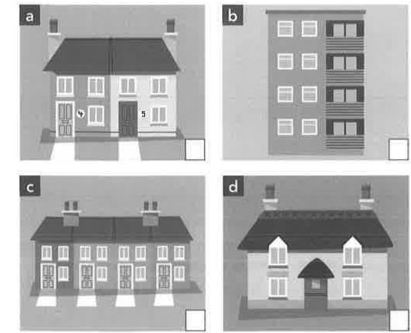
1 Complete the definitions with a type of house. Match four of them to the pictures.

- A ______________ is not joined to another house.
- A______________ is a small house in a village or in the countryside.
- A______________ is a house that doesn't have any stairs.
- A ______________ is in a row of houses that are joined together.
- A______________ is usually on one floor of a larger building.
- A______________ is joined to another house by one wall that they share.

2 Find these words in the wordsearch: PODEIS MARCAR LAS PALABRAS EN LA SOPA DE LETRAS SELECCIONANDO LA PALABRA QUE ENCONTREIS Y CAMBIANDO EL COLOR DEL TEXTO

factory • outskirts • port • square • skyscraper • suburbs • town hall

I | Z | C | O | R | G | M | S | P | S | Z | G | N | Y
S | Q | U | A | R | E | B | B | K | 0 | Y | X | Q | P
L | M | D | Z | W | R | C | Y | B | X | R | F | X | I
T | I | Z | X | U | X | S | E | P | U | H | T | F | Y
B | Q | A | B | B | C | Z | O | C | G | E | G | P | R
F | B | U | H | R | S | T | R | ¡ | K | S | T | U | O
N | S | C | A | N | C | U | K | Q | I | S | A | T | T
H | F | P | S | N | W | L | L | C | J | N | W | H | C
Q | E | A | J | W | Y | O | D | D | N | I | M | R | A
R | D | W | S | V | N | N | T | S | ¡ | S | E | O | F

3 Complete the sentences with an appropriate adjective from the box.
busy • clean • crowded • dirty • empty historic • lively • noisy • quiet

- Ella really liked Dubai because it's so_______________________ There's no rubbish anywhere.
- The streets are so _______________________ in the evening. You can often see street performers, and music and dancing.
- I don't like going to the town centre on a Saturday.The shops are_______________________ and there are long queues.
- Most capital cities in central Europe have_______________________ centres with buildings_______________________ that are several hundred years old.
- I live in a _______________________ a village, not much happens there at weekends.

