Friday 20
Hello children’s:
Today is the last Friday.
The photos that you take send them to me through the mail of a mobile phone, I get the same

Nº 1. If you haven’t finished continue with the page 33

Page 33:
Take the page 79
Draw and make your own Cubist cityscape collage.
Step 1: Draw some city buildings.
Step 2: Divide your artwork with lines.
Step 3: Draw windows, doors and objects from different perspectives.
Step 4: Cut and glue photos from magazines. Colour the rest of the cityscape.

Nº 2. We go to the pages 17 and 75.
Let’s imagine how would you like our room to be?
Take the page 77 and follow the steps on page 17.
When you finish you can paint it as you want.

Nº 3 Os voy a escribir diferentes manualidades por si os apetece hacer en estas “estupendas” vacaciones en nuestras casas.

- En el libro de arts:
1º page 56: make a necklace or bracelets with cardboards.
2º page 57: design you own spring glass.
3º Haz tu propio atrapa-sueños. Aprieta control y haz cilc con el ratón encima del enlace.
Se necesita un alambre fino o cartón moldeable.
Cuerda, lana y abalorios.
https://www.youtube.com/watch?v=LaKttMq-Bmw
4º Decorative balls.
You need small or médium balloons, liquid glue, a brush and coloured wool.
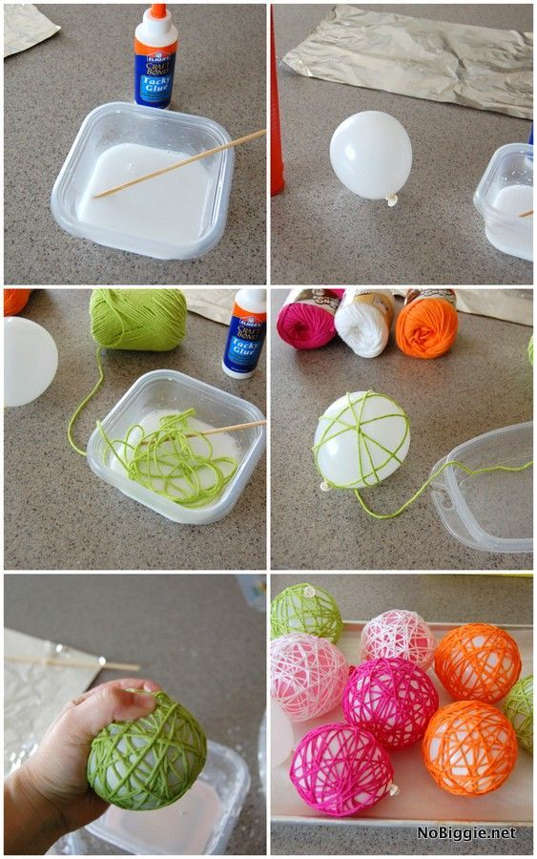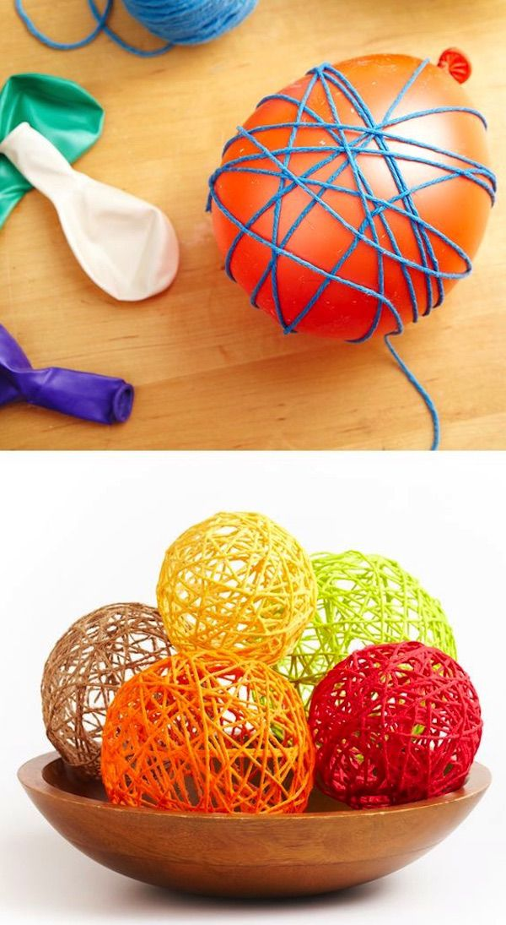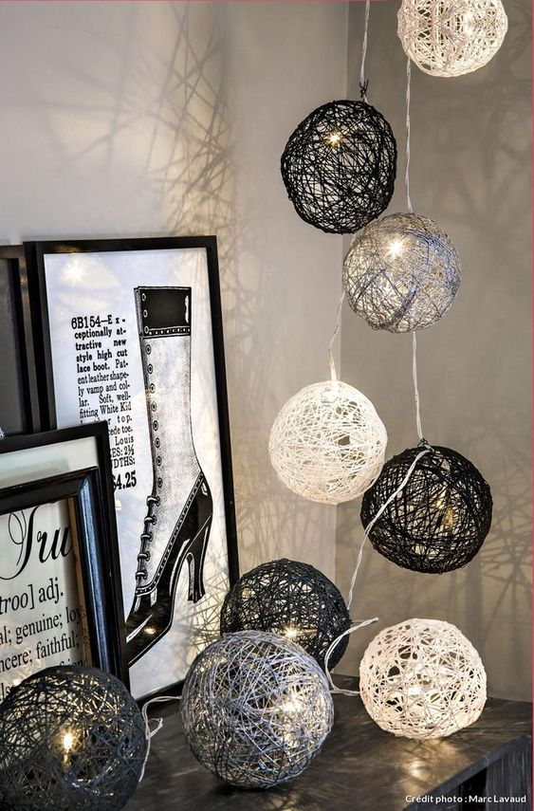

I WISH YOU HAVE A GREAT TIME!

“Una vez hechas las tareas y los ejercicios y para dudas, puedes contactar conmigo en el siguiente e-mail”:
veronica.tauler@sanviatorvalladolid.com

