

ENGLISH 1º ESO A Y 1º ESO B (Bilingual Section)

Hola,
A lo mejor estás un poco decepcionado por no haber pasado a la fase 1 en la que todos tanto ansiamos estar para poder ir normalizando un poco más nuestra vida y sobre todo, para poder vernos con nuestros amigos y nuestros familiares más queridos. Pero… ¡ya queda menos! Sigamos haciendo las cosas bien, guardando la distancia o, usando mascarilla en sitios donde sea difícil guardarla y pronto estaremos ahí.
Lee estas informaciones que da el gobierno a los ciudadanos de Needham en Massachusetts, EEUU.

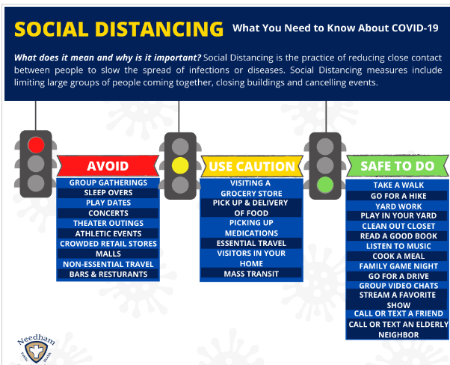
Have a really nice week!
María Jesús

Monday, May 18th

^{Remember:}
For = desde hace van con Present Perfect
Since = desde (have/has + participio)

- Write for or since . Translate the expresions.

Ex: Since yesterday ----------- Desde ayer
- ……………….three years
- ………………. Monday
- ………………. your birthday
- ………………… April, 3rd
- ………………… two hours
- ………………….. ten minutes
- ……………………. 2019
- ………………………tomorrow morning
- ……………………..10.30 am

^{Remember:}
- ALREADY = YA - We have already drunk some water
- JUST= ACABAR DE- I have just cleaned my bedroom

- ^{Write the Present Perfect}
- I __________________ (already/talk) to him
- They __________________ (just/repair the car)
- We______________________ (not paint) the house yet.
- He _____________________ (work) here for over 10 years
- Sarah _______________________ (not play) this game before
- They _____________________ (already/buy) some cola for the party
- I _________________________ (just/lose) my key
- She _____________________ (not be) to the supermarket yet
- My friends _________________ (not do) their homework yet
- I _____________________ (already/write) 12 mails

- Write sentences with the PRESENT PERFECT

1. Juan´s hair was dirty. Now it’s clean. (wash) - Juan has washed his hair
2. Look! Mrs. Martín has got a new car. (buy) ______________________
3. Maria was 70 kg. Now she’s 70. (lose weight) - ___________________
4. Your sister is looking for her pen. (lose) _________________________ 5. Mary is on holiday in France. (go) _______________________________________
6. Mr. McDonals was in Australia last week. He’s back in London now. (be)
______________________________________
7. Antonio played basketball yesterday. Now he can’t walk; his leg is in plaster. (break) ________________________________________

Tuesday, May 19th
^{Remember:}
YET = TODAVÍA. Va al final de la oración. Sólo en oraciones negativas
( OJO: en español todavía puede ir al principio,al final o en medio de una oración. Yet en inglés sólo al final)

I haven´t started my homework yet= Todavía no he empezado los deberes
My sister hasn´t been to the bank yet = Mi hermana todavía no ha ido al banco
I haven´t paint the door yet= Todavía no he pintado la puerta

1. Traduce al inglés:
a. No he visitado Londres todavía-
b. Todavía no hemos hecho los deberes-
c. Todavía no he visto la película-
d. Mis padres todavía no han hecho la cena (cook dinner)

2. Present Perfect + since/for
a. She _______________ (live) here _______ 2006
b. I _____________(be) on holiday ________ six weeks
c. My teacher ____________ (teach) at my school _______ 2009
d. I ______________ (see) him 4 times _____ yesterday
e. My mum _________ (work) for Reanault _______ 7 years now.
f. I _______________ (eat) 6 sandwiches _______ 8´oclock in the morning

Wednesday + Thursday, May 20th / 21st
1 .Read the text 2. Answer the questions 3. Read the text aloud
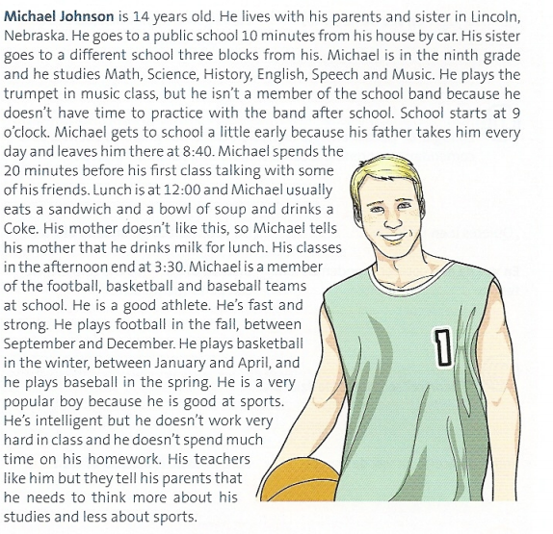

- Is Michael 12 years old?
- How old is he?
- Who does he live with?
- Where does he live?
- What kind of school does he go to?
- Is the school far from his house?
- Is it near from his house?
- How far is it from his house by car?
- Is school far from his sister´s school?
- How far is it from his sister´s school?
- What grade is he in?

- Does he study 3 subjects?

- How many subjects does he study?

- Does he play a musical Instrument in music class?

- What instrument does he play?

- Is he a member of the school band?

- Why?

- When does the band practice?

- What time does school start?

- When does he get to school?

- Why does he get to school a little early?

- How often does his father take him to school?

- What time does his father leave him at school?

- Does Michael spend the 20 minutes studying?

- What does he spend the time doing?

- Where does he have lunch?

- What time does he have lunch?

- What does he drink?

- Does his mother know than he drinks Coke?

- What does she think he drinks?

- Why does she think he drinks milk?

- Does Michael have classes after lunch?

- What time does he finish school?

- Does Michael like sport?

- Is he a good athlete or a bad athlete?

- Does he play any sport at school?

- How many sports does he play?

- Does he play basketball?

- What other two sports does he play?

- Is he a member of the school team in these sports?

- When does he play football?

- When does he play basketball?

- When does he play baseball?

- Is he a popular boy at school?

