RELIGION
Today we are going to learn the sacraments.
First of all, we need to know what the sacraments are. The sacraments are actions in which the believer manifests his relationship with God. There are 7 sacraments.
What did he give them to us for? To give us the grace, the love and the strength to fight against the difficulties of life.
What are the seven sacraments?
- BAPTISM
When we are born, we are born with the first of our sins. It's called Original Sin, and it was committed by our first parents Adam and Eve. By being baptized, we are cleansed from this sin, become children of God, and become part of the Church. God is very happy when the priest, by pouring holy water on the baptized, says: "I baptize you in the name of the Father, the Son and the Holy Spirit.”
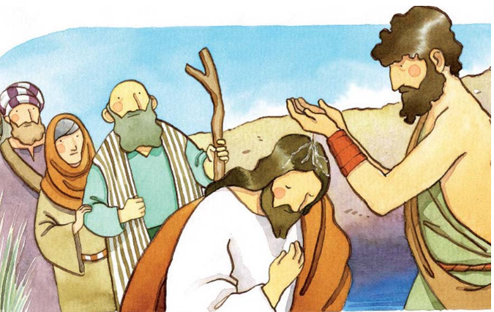
Do you remember who baptized Jesus? For the one who did not remember was John, in the river Jordan
- CONFIRMATION
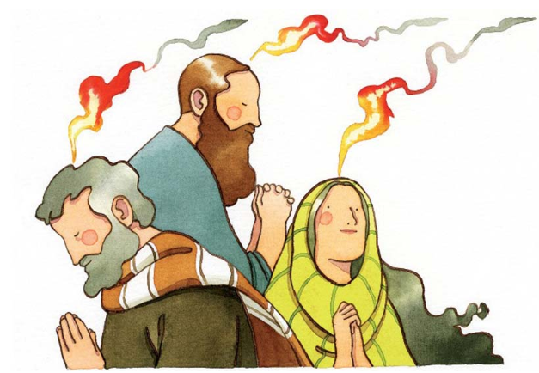
God increases our faith so that we can be sure that He is with us until we get to Heaven. Finally, He increases our charity so that we love Him and those around us more. In this case, it must be a bishop who lays his hands on the confirmer and anoints us with oil (the Holy Chrism), while saying: "Receive the gift of the Holy Spirit for this sign".
- EUCHARIST
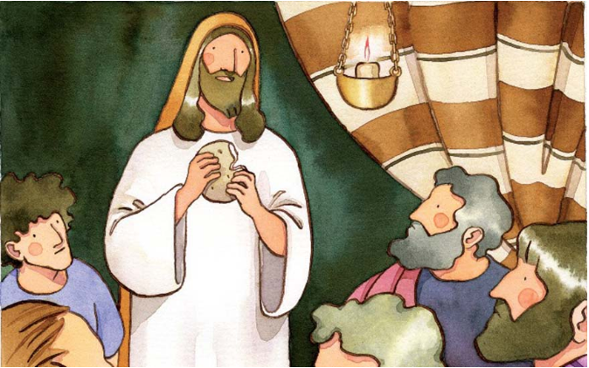
Every day Jesus turns the bread and wine into his Body and Blood at Mass. This happens in a moment called Consecration. Jesus instituted this sacrament at the Last Supper with the twelve apostles. We are forgiven for our sins and by eating the body and blood of Christ we have Jesus within us.
(La Eucaristía es la Comunión, en España se suele tomar la eucaristía entre los 9 y 10 años.)
- PENITENCE
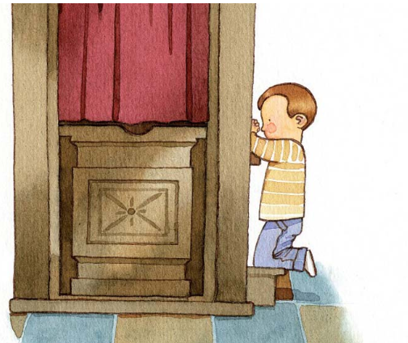
This sacrament is a gift from God! Through a priest who listens to our sins when we go to confession in confidence with him, God forgives us everything in which we have offended him. However, we have to go well repentant for the evil we have done and the good we have failed to do. Moreover, it gives us tremendous peace and increases our strength to be good Christians, good children of God.
(La Penitencia es la confesión, nos confesamos de nuestros pecados)

- UNITY OF THE SICK
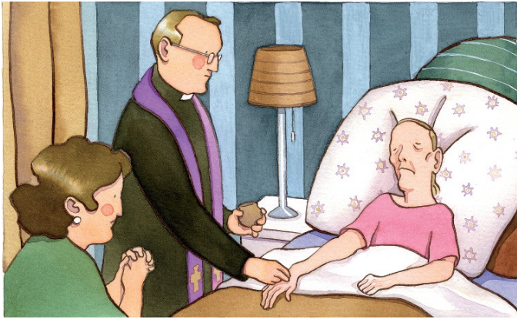
God loves the sick. When someone is very sick, or is very old and may die soon, he needs God's help for that moment. Therefore, this sacrament helps to have strength, peace and courage. It also forgives all the sins of the sick and prepares them for the time of death. It is like creating a union with the Passion that Christ suffered. The sick help with their pain to carry the Cross to Jesus and at the same time, God helps them in their last moments of life.

- PRIESTLY ORDER
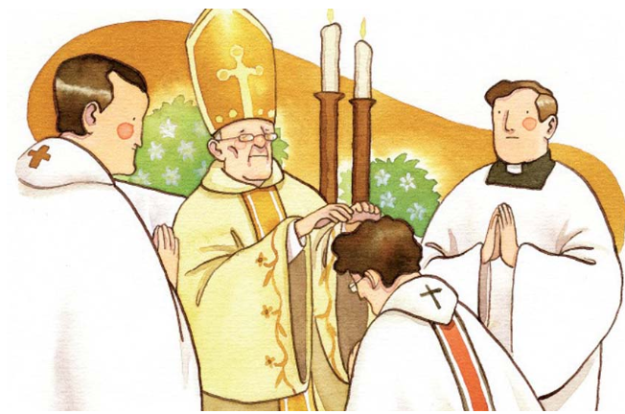
This is received only by those who have a vocation to the priesthood, who are then able to administer all these sacraments. It is a bishop who imposes his hands and prays over the new priest, consecrating him. Priestly ordination gives a special outpouring of the Holy Spirit and has a special characteristic: whoever receives this sacrament will be a priest forever.

- MARRIAGE
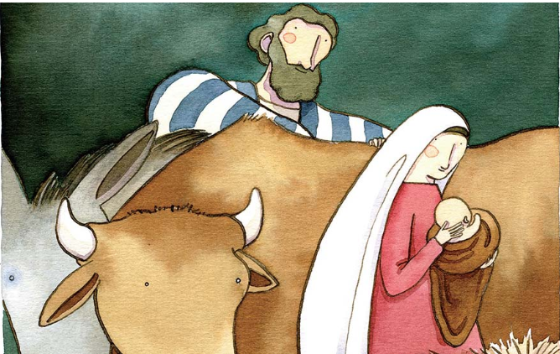
This sacrament is the union between a man and a woman forever. When they are married in the Church, it is God who is uniting their bodies and souls. Those who marry must not break that marriage: "What God has joined together let no man put asunder. (St. Mark 10:9). The model that men and women have to follow is that of the Holy Family: Jesus, the Virgin Mary and St. Joseph.

Learn very well what the sacraments are. Next Thursday, I will give you a short test to see if you have learned it.
Aprenderos muy bien los sacramentos. El próximo jueves os hare una pequeña prueba para ver si os lo habéis aprendido.
Si alguien no entiende alguna palabra, os dejo a continuación un enlace para que lo podáis traducir:
https://www.deepl.com/es/translator
También os dejo un enlace con la explicación en español, pero leerlo también en inglés para ver el vocabulario. También he añadido o quitado cosas: https://catholic-link.com/7-sacramentos-explicados-nino/
Cualquier duda que tengáis podéis contactar conmigo en el siguiente email: maria.morro@sanviatorvalladolid.com

