

ENGLISH 1º ESO A Y 1º ESO B (Bilingual Section)

Dear student,
And… finally it is June!! Two more weeks and we can go on holidays!! Can you imagine it?? You will not have to sit at the computer and do lots of homerwork, you can get up late, you can go out with your friends… Life will be wonderful!!

Monday, June 1st –
Vamos a empezar con el Will-future.
- Se construye:
Sujeto + will + infinitivo
- Se utiliza con expresiones de tiempo que indican tiempo futuro:

tomorrow, the day after tomorrow (pasado mañana) , next week, next month, next year, in two days, in three weeks, in five years….
- Se utiliza para expresar algo no planeado, decisiones espontaneas u ofertas.
- Futuro de go:
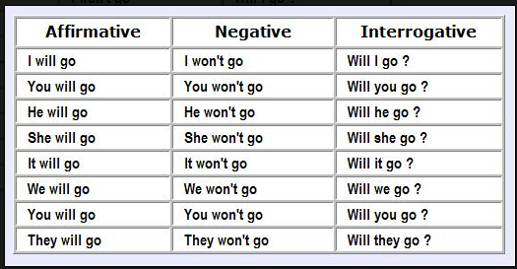

- Write de future affirmative of open the door
I will open the door = voy a abrir la puerta/ abriré la puerta
You
He/she
…

- Write the future negative of come late
I won´t come late = no llegaré tarde/no voy a llegar tarde
You
…

- Write the future interrogative of be at home
Will I be at home? = ¿estaré en casa?
Will you be at home = ¿estarás en casa?
…..

- Complete the sentences with will in positive (yes), negative (no) or interrogative (?) form and translate them:
- They (help) ____________you . (yes)
- Maybe he (stay) ________________ at home tonight.(yes)
- My friends (go) _________________ probably to the beach on Thursday.(no)
- Peter (buy) ________________ the tickets for the concert.(no)
- I hope that James (cook) _________________ the dinner tonight(yes)
- _____________ Real Madrid __________ (win) the league? (?)
- My sister (answer)________________ the question.(not)
- _________ you _______________ (eat) the fish?
No me mandes los ejercicios de hoy lunes, los vamos a corregir mañana.

Tuesday, June 2nd
Hoy vamos a tener una clase online a las 9.30. Te enviaré la invitación.
Ten a mano el cuaderno, un boli y los ejercicios de ayer lunes. Ten a mano también estos (sin hacer)
Ex. 1.
Help: “ The bags are heavy!” - “Wait a second, I ________ help you!”
Make: “You look hungry!- “Wait, mum _____________ you a sandwich”
Pay: “ I forgot my money at home”- “Never mind,I ___________ the tickets”
Take: “Look! It started to rain!”- “Oh, we ________________ an umbrella”
Give: “I´m cold!”- “Oh, I ________________________ you my jackett”
Help: “ Look at this mess in the kitchen!”- “Wait, I________________ help you”
Not take: “ Look, the weather is fantastic!, I _________________ the bus to school.
Go: “It is already 12 o´clock!”- Oh- really? I think I ________________ to bed”
Not clean: “Look at this huge spider! I _______________ clean the room!

2. Helen está viajando por Europa. Completa con el presente (is), el futuro (will be ) o el pasado (was)
Yesterday she __________ in Madrid.
Tomorrow she ____________ in Paris.
Last week she _____________ in London.
Next week Helen ___________ in Brussels.
At the moment _____________ Amsterdam.
Three days ago ________________ in Berlin.
At the end of the trip ______________ very tired

Wednesday, June 3rd
Student´s book page 44 : Ex.1, 2, 3a, 4

Thursday, June 4th
Repasa la lista de los verbos irregulares. Comprueba que la sabes.

That´s all for this week!

